Python Assignment [18-12-2023]

By Karthikeyan K R

**Class and Object**

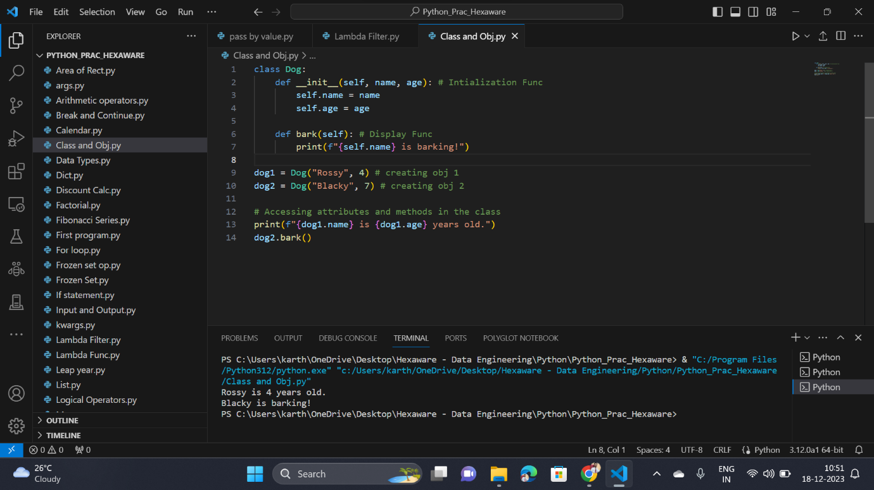

**Inheritance in python:**

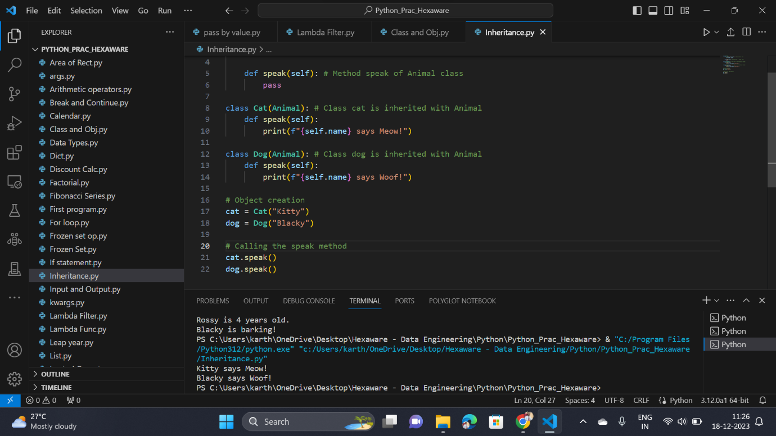

**Encapsulation in Python:**

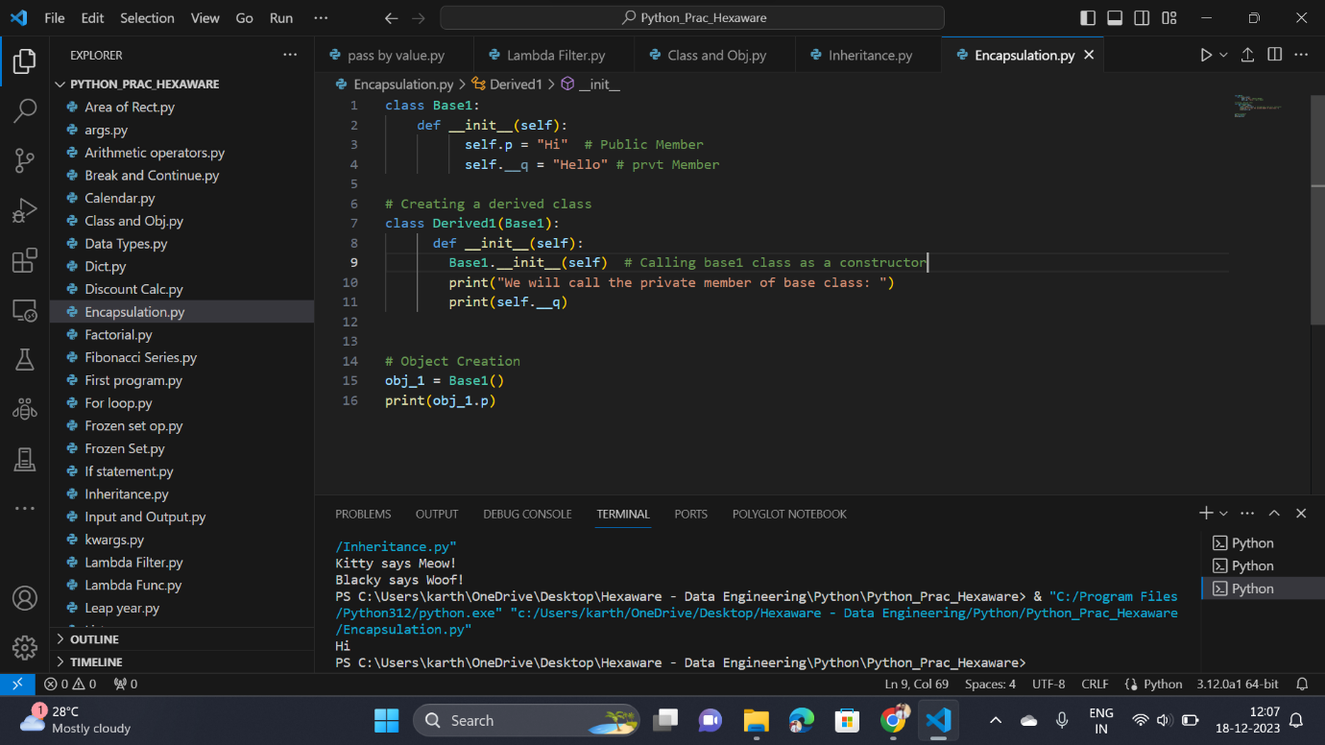

**Polymorphism in Python:**

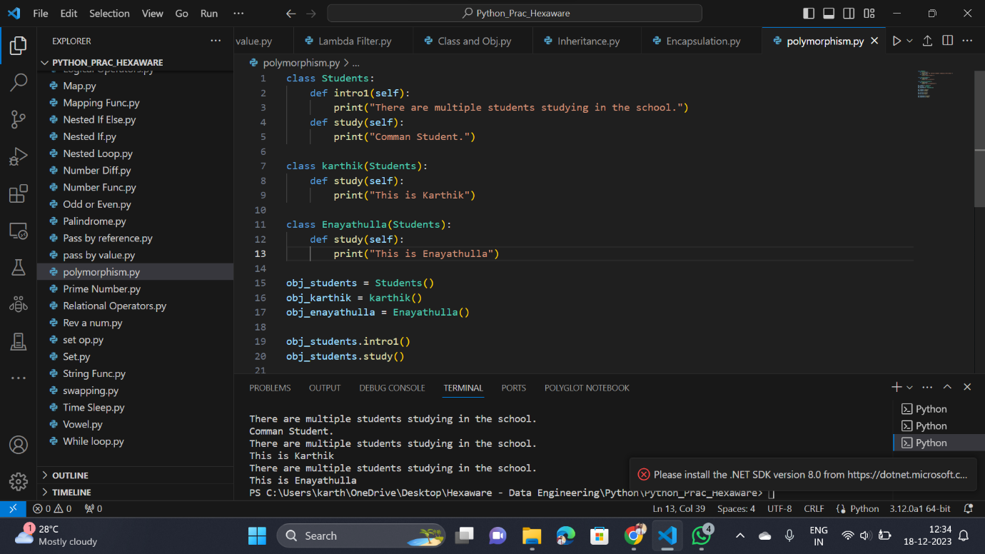

**Method Overriding:**

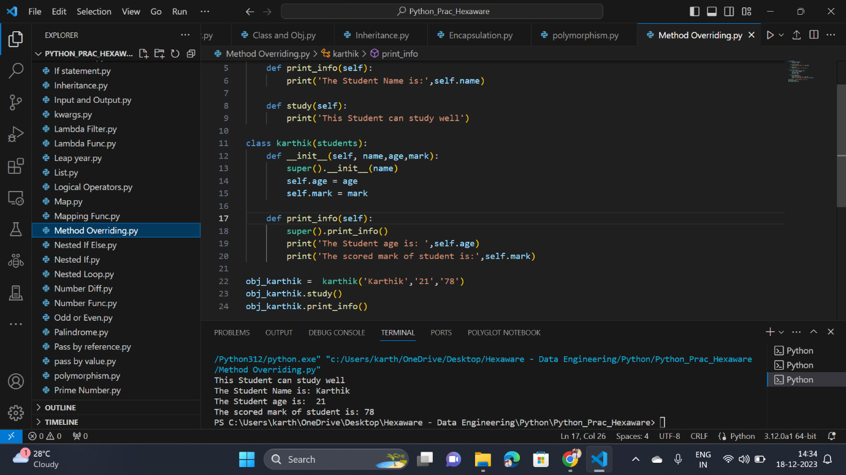

**Single Inheritance:**

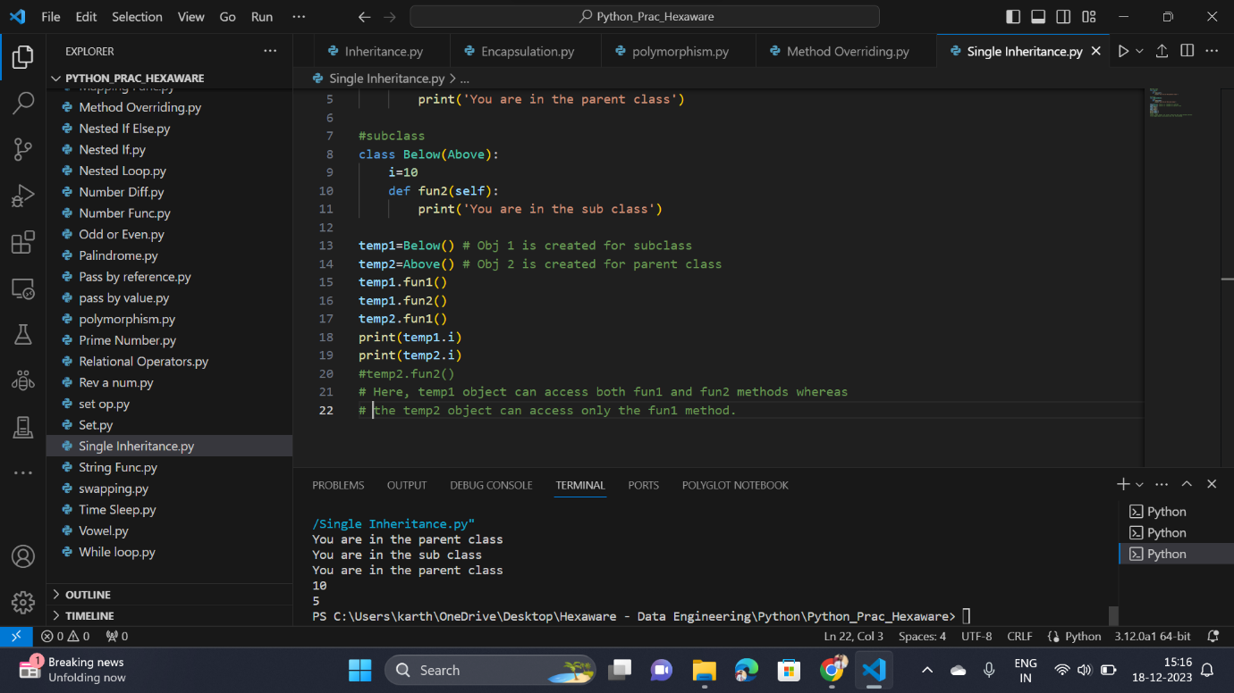

**Multiple Inheritance:**

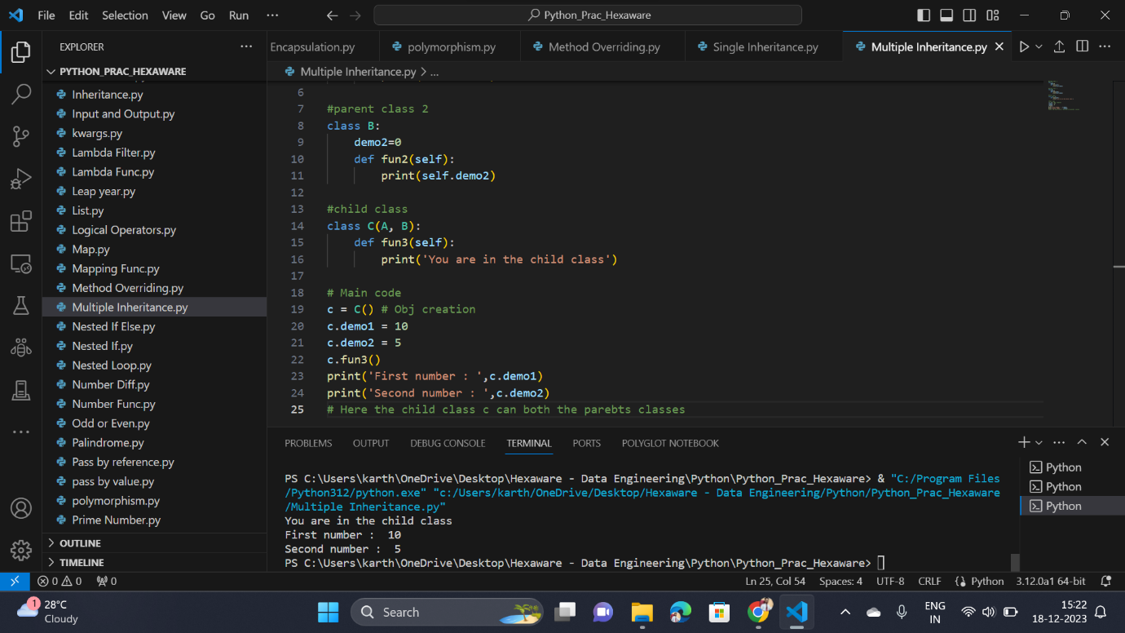

**Multilevel Inheritance:**

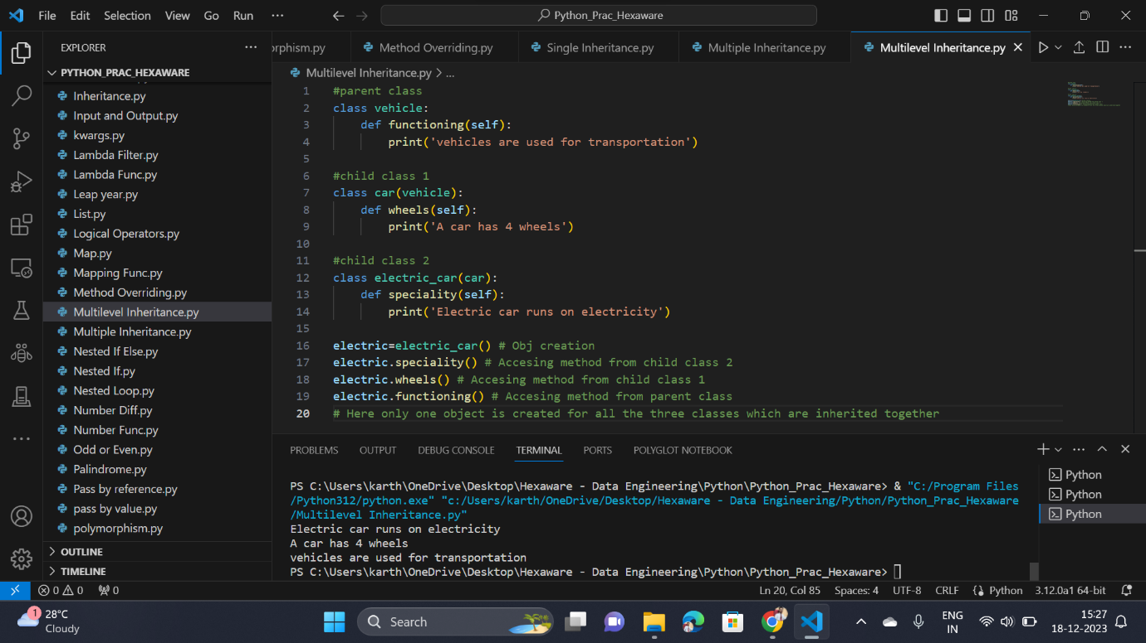

**Hierarchical Inheritance:**

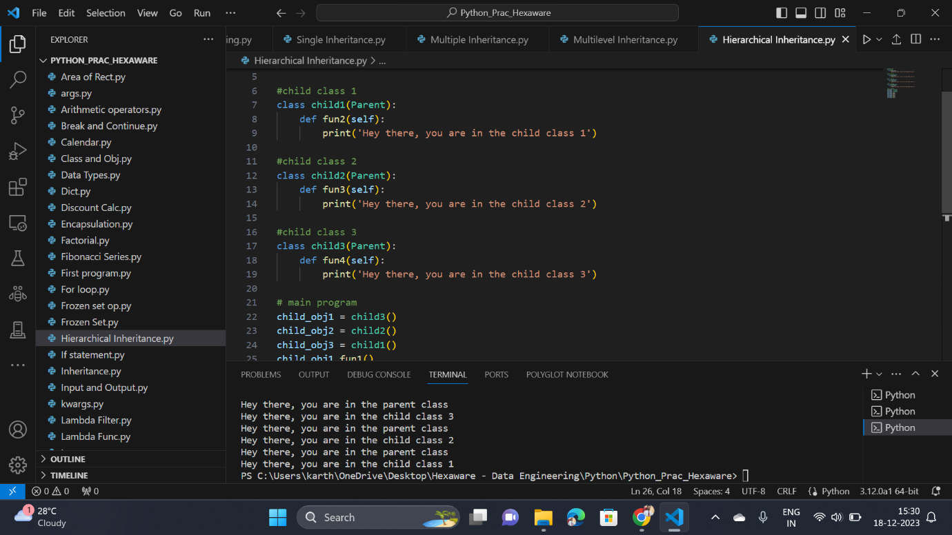

**File Handling in python:**

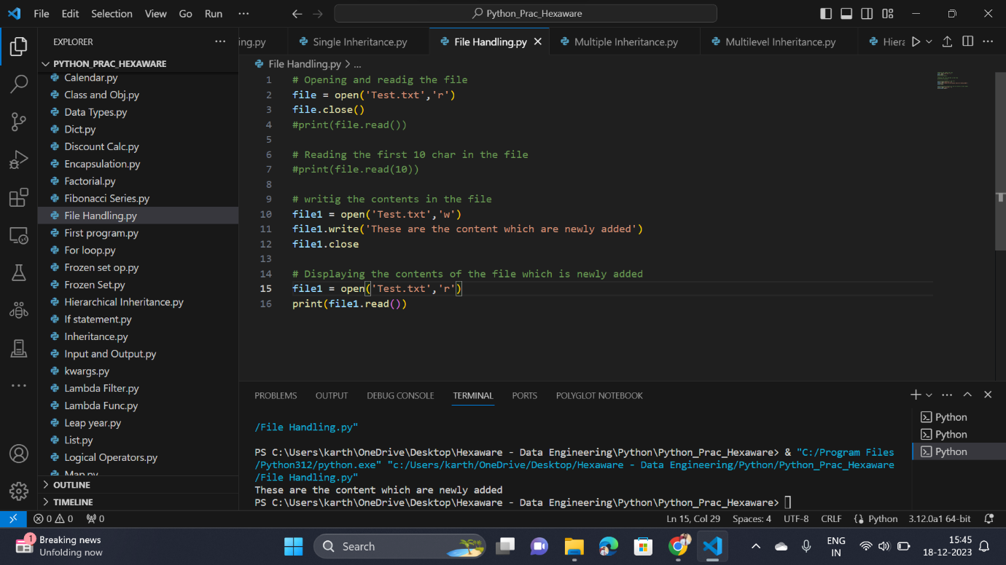

**Modules in Python:**

